

SCHOOL OF ENGINEERING AND TECHNOLOGY

Department of Computer Science and Engineering

Jain Global Campus, Kanakapura Taluk - 562112  
Ramanagara District, Karnataka, India

**2020 - 2021**

Mini-Project Report on

“College ERP”

Submitted in partial fulfilment for the course

WEB TECHNOLOGIES LAB as part of the degree of

Bachelor of Technology

in

COMPUTER SCIENCE AND ENGINEERING

Submitted by

Prati Jain

18BTRCS066

Ishika Sarraf

18BTRCS108

Riya Garg

18BTRCT036

Jahanvi Khatri

18BTTCS004

Under the guidance of

**M. Rajani Shree**

Assistant Professor

Department of Computer Science and Engineering

School of Engineering & Technology

Jain Deemed to Be University



SCHOOL OF ENGINEERING & TECHNOLOGY

**Department of Computer Science & Engineering**

Jain Global campus

Kanakapura Taluk - 562112  
Ramanagara District, Karnataka, India

CERTIFICATE

This is to certify that the mini-project work on **College ERP** as part of **18ESCS03 –WEB TECHNOLOGY LAB** is carried out by **Prati Jain(18BTRCS066), Ishika Sarraf (18BTRCS108),** **Riya Garg(18BTRCT036), Jahanvi Khatri (18BTTCS004),** are the bonafide students of Bachelor of Technology in Computer Science and Engineering at the School of Engineering & Technology, Jain University, Bangalore, during the year **2020‑2021.**

|  |  |
| --- | --- |
| **Mrs.M. Rajani Shree** | **Dr. Narayanaswamy R** |
| Associate Professor  Dept. of CS&E,  School of Engineering & Technology,  Jain University | Head of the Department, Dept. of CS&E,  School of Engineering & Technology,  Jain University |

<

DECLARATION

**Prati Jain(18BTRCS066), Ishika Sarraf (18BTRCS108),** **Riya Garg(18BTRCT036), Jahanvi Khatri (18BTTCS004)** are the students of fifth semester B.Tech in **Computer Science & Engineering**, at School of Engineering & Technology, **Jain** **University**. We hereby declare that the mini-project titled **College ERP** has been carried out by us and submitted in the partial fulfilment for the course **18ESCS03 – WEB TECHNOLOGY LAB** as part of our degree in **Bachelor of Technology in Computer Science & Engineering** during the academic year **2020‑2021**.

|  |  |
| --- | --- |
|  | **Signature** |
| Name1: **Prati Jain**  USN :**18BTRCS066** |  |
| Name2:  **Ishika Sarraf**  USN: **18BTRCS108** |  |
| Name3: **Riya Garg**  USN: **18BTRCT036** |  |
| Name4: **Jahanvi Khatri**  USN: **18BTTCS004** |  |
| Place: Bangalore  Date :12-12-2020 |  |

**ACKNOWLEDGEMENT**

*It is a great pleasure for me to acknowledge the assistance and support of a large number of individuals who have been responsible for the successful completion of this mini-project work.*

*We would like to thank* ***Dr. Hariprasad S A****,* ***Director, School of Engineering & Technology****,* ***Jain University*** *for his constant encouragement and expert advice.*

*It is a matter of immense pleasure to express our sincere thanks to* ***Dr. Narayana Swamy****,* ***Head of the department****,* ***Computer Science & Engineering****,* ***Jain Deemed To Be University,*** *for providing right academic guidance that made our task possible.*

*We would like to thank our guide* ***M. Rajani Shree****,* ***Assistant Professor****,* ***Dept. of Computer Science & Engineering****,* ***Jain Deemed To Be University****, for sparing her valuable time to extend help in the project work.*

*We would like to thank one and all who directly or indirectly helped us in completing the project work successfully.*

***Signature of Students***

ABSTRACT

This report specifies the various processes and techniques used in gathering requirements, designing, implementing and testing for the project on college management system. The problems regarding the current system in the college were analysed and noted. This project aims to solve some of those problems and thus, add more value to the current system. The requirements were gathered from all the stakeholders and based on that we created a requirement models and designed the software based on the based. The project was implemented in the form of a website using PHP.

Using the various resources and tools we gathered along the way, we implemented the college ERP system using some features that solve the current problems in the system. The software was also tested using the various testing methods and results were positive.

Thus, the results can be integrated in the current ERP system to improve it’s working and solve some of the existing problems.

**TABLE OF CONTENTS**

1. **INTRODUCTION**

**1.1 Identification**

**1.2 Purpose**

**1.3 Scope of the project**

**1.4 Hardware Specification**

**1.5 Software Specification**

1. **LITERATURE SURVEY**

**2.1Existing System**

**2.2Proposed System**

**2.3Feasibility Study**

**3. OVERALL DESCRIPTION**

**3.1 Product Perspective**

**3.2 Product Features**

**3.3 User Class and Characteristics**

**4. SYSTEM ANALYSIS & DESIGN**

**4.1 Requirement Specification**

**4.2 Non-Functional Requirement**

**4.3 Code**

**4.4 Testing**

**5. RESULT**

**6. CONCLUSIONS**

**7. REFERENCES**

1 Introduction

Enterprise Resource Planning system, popularly known as ERP system, the descendant of MRPII offers the answer to the economic and productivity troubles of manufacturing and service enterprises. Thus, the ERP system has become very popular as an enterprise management software tool. It was the larger companies that have opted to use the ERP systems initially. However, the use of ERP has changed and today the term can refer to any type of company, no matter what industry it falls in. In fact, ERP systems are used in almost any type of organization - large or small. The latest ERP tools available in the market today can cover a wide range of functions and integrate them into one unified database. This made ERP to land up into higher educational institutes. In today’s competitive business world usage of ERP system is becoming a must for any educational organization to meet the challenges faced in their business process and to have a cutting edge. Studies also reveal that organizations that don’t have an ERP implemented are facing numerous problems in their internal processing like attendance management, payroll management, quick decision making, etc. So, in order to be different and ready for action the institutes need a central resource planning that can manage the entire information and operations of the institutions.

1.1 Identification

The software system being considered for development is referred to as College ERP System. The customer providing specifications for the system is Prof. Rajanishree and students, Department of CSE FET. The ultimate customer, or end-user, of the system will be the teachers and the HoDs of each department in FET, Students and Administrators. This is a new project effort, so the version under development is version 1.0.

1.2 Purpose

The purpose is to design software for college database which contains up to date or accurate information of the college. That should improve efficiency and flexibility of college record management and to provide a common and or simple platform for everyone to access the student’s information. College Automation System consists of different modules such as faculty, admin etc. Our main purpose is to create a software which will manage the working of these different modules. The interconnectivity among modules reduces the time to perform different operational task.

1.3 Scope of the Project

College management is becoming a very essential component in education in this modern-day age. With the help of College Automation System, we can gather all the useful information needed to the management in few clicks. The College ERP system now computerizes all the details that are maintained manually. Once the details are fed into the system or computer there is no need for various persons to deal with separate sections. Only a person is enough to maintain all the reports and records. The security can also be given as per the user requirement.

1.4 Hardware Specification

Since neither the mobile application nor the web portal have any designated hardware, it does not have any direct hardware interfaces. Any browser can be used to access the webapp

1.5 Software Specification

The following is a list of software used in making of the project

* Operating System: We have chosen Windows operating system for its best support and user-friendliness.
* Front end: HTML, CSS, JavaScript

1. HTML: HTML is used to create and save web document. E.g., Notepad
2. CSS: (Cascading Style Sheets) Create attractive Layout
3. JavaScript: it is a programming language, commonly use with web browsers.

* Back end: PHP, MySQL

1. PHP: Hypertext Pre-processor (PHP) is a technology that allows software developers to create dynamically generated web pages, in HTML, XML, or other document types, as per client request. PHP is open-source software.
2. MySQL: MySQL is a database, widely used for accessing querying, updating, and managing data in databases.

* Web Server: XAMPP Server
* Web Browser: Google Chrome, Mozilla Firefox, Microsoft Edge.

2. LITERATURE SURVEY

2.1 Existing System

In the existing College Management System (College ERP) no database is maintained. All the documents are in papers and kept in files. This eats up much time in preparing the documents and also searching relevant documents from the heap of files take up valuable time of the employees. In existing College Management System PHP, there are many more flaws apart from it too, such as data files can be lost when the management keep track of all the activities into files and many more.

2.2 Proposed System

The software is prepared by programming language PHP and MySQL database. The software will manage all the functionalities of the college. The software is on one hand error free and use friendly and on the other hand will reduce consumption of paper, time, and power that is to say it will reduce costs to a great extent. The site opens with a home page that gives introduction of the college. There are subjects tab describing different courses offered, student tab showing all the students list.

The proposed system can overcome all the limitations of existing system. The system provides proper security and reduces the manual work.

* Security of data
* Proper control of higher official
* Minimize manual data entry
* Minimum time needed for manual data processing
* Greater efficiency

2.3 Feasibility Study

After doing the project College Management System, study and analysing all the existing or required functionalities of the system, the next task is to do the feasibility study for the project. All projects are feasible-given unlimited resources and infinite time.

Feasibility study includes consideration of all the possible ways to provide a solution to the given problem. The proposed solution should satisfy all the user requirements and should be flexible enough so that future changes can be easily done based on the future upcoming requirements.

**A. Economical Feasibility:**

This is a very important aspect to be considered while developing a project. We decided the technology based on minimum possible cost factor.

* All hardware and software cost has to be borne by the organization.
* Overall, we have estimated that befits the organization is going to receive from the proposed system will surely overcome the initial costs and the later on running cost for system.

**B. Technical Feasibility:**

This included the study of function, performances and the constraints that may affect the ability to achieve an acceptable system. For this feasibility study, we studied complete functionality to be provided in the system, as described in the System. Requirement Specification (SRS), and checked if everything was possible using different type of frontend and backend platform.

**C. Operation Feasibility:**

No doubt the proposed system is fully GUI based that is very user friendly and all inputs to be taken all self-explanatory even to a layman. Besides, a proper training has been conducted to let know the essence of the system to the users so that they feel comfortable with new system. As far our study is concerned the clients are comfortable and happy as the system has cut down their loads and doing.

3 Overall Description

3.1 Product Perspective

ERP means the techniques and concepts for integrated management of business as a whole, from the viewpoint of effective use of management resources to improve the efficiency of enterprise management. A fully integrated web-based ERP will capture and create accurate, consistent and timely relevant data, and assist in intelligent business decision-making. The primary purpose of E-college is to provide mechanisms for automated processing and management of the entire institution. It reduces data error, ensures that information is managed efficiently and is always up-to-date. Complete student histories for all years, can easily be searched, viewed and reported on press of button.

The security issue within ERP has been there for a long time, but most of the solutions are based on the assumption that an ERP system is a closed environment. Higher education institutions are persisting in the IS era by adopting and implementing ERP system. The need to evaluate their benefits and impacts on organizations and individuals are increasingly essential.

3.2 Product Features

* Each teacher can enter marks for their respective students.
* The administrator will be able to view and update information such as classes, teachers, students, courses.
* Provides the searching facilities of faculties,
* Manage the information of college
* Manage the information of students

3.3 User Classes and Characteristics

There are several types of end users for the college ERP system. Each of these classes have their own set of features.

1. **Admin:** All the activities are visible only by authorized persons or admins of the software. They can access it any time and can change it anytime. They have the access to add and remove various features to the system as well. Admin have their own panels too.

2. **Faculty:** Details about the faculty. Faculty have their own panel where they can update their profile and details. They add and update students, add marks for the students for exam.

4 System Analysis & Design

4.1 Requirement Specification

The basic information required for our project are:

**1.** **Student and staff information:** Information regarding students, teachers and courses are stored in the database. Every user can view only certain information based on their user class. For example, a teacher can view student and course information that they are handling.

**2.Marks Entry:** Marks entry is the main feature of the College ERP system. Hence, the priority is high. Teachers update the marks of the students who are part of her class.

**3 Exams:** Exams are one of the important aspects of College ERP. User can view the information about exams.

4.2 Non-functional requirements

1. Safety requirements: If there is extensive damage to a wide portion of the database due to catastrophic failure, such as a disk crash, the recovery method restores a past copy of the database that was backed up to archival storage (typically tape) and reconstructs a more current state by reapplying or redoing the operations of committed transactions from the backed-up log, up to the time of failure.

2. Security requirements: The database contains sensitive information of all the students and staff. Therefore, optimal security measures must be taken to ensure data is safe from unauthorized users.

3. Software Quality Attributes:

* **Availability:** The users must always be able to view their information so that they can keep track regularly.
* **Correctness:** The information about marks must be correct to not feed wrong information to the users.
* **Portability:** The users access the ERP from various platforms such as desktops and mobile phones. The webapp must be portable to all platforms and the user experience must be optimal.

4.3 Code

4.4 Testing

Once the code is generated, the website testing begins. Different testing methodologies are done to unravel the bugs that were committed during the previous phases. Different testing methodologies are used:

* Acceptance testing
* White Box Testing
* Black Box Testing

### Acceptance testing - Acceptance testing can mean one of two things:

1. A smoke test is used as an acceptance test prior to introducing a build to the main testing process.
2. Acceptance testing performed by the customer is known as user acceptance testing (UAT).
3. **Black box testing** - Black box testing treats the software as a "black box," without any knowledge of internal implementation. Black box testing methods include: equivalence partitioning, boundary value analysis, all-pairs testing, fuzz testing, model-based testing, traceability matrix, exploratory testing and specification-based testing.
4. **White box testing** - White box testing, by contrast to black box testing, is when the tester has access to the internal data structures and algorithms (and the code that implement these). White box testing methods can also be used to evaluate the completeness of a test suite that was created with black box testing methods. This allows the software team to examine parts of a system that are rarely tested and ensures that the most important function points have been tested.

5 RESULT

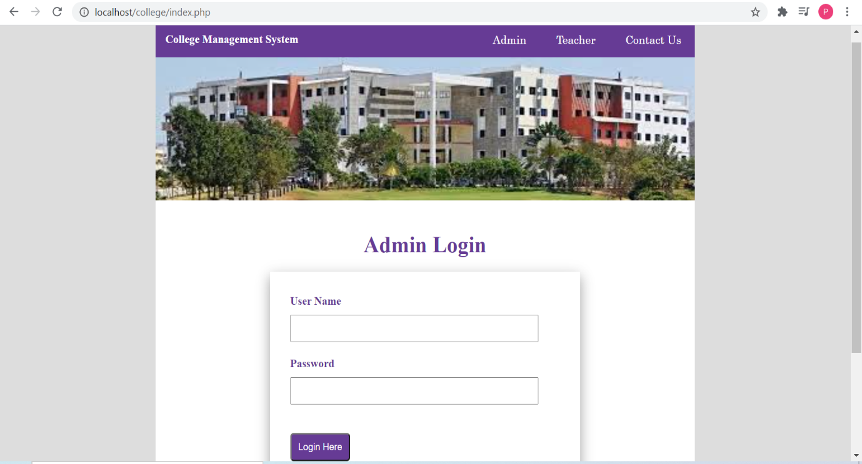

Admin Login Page

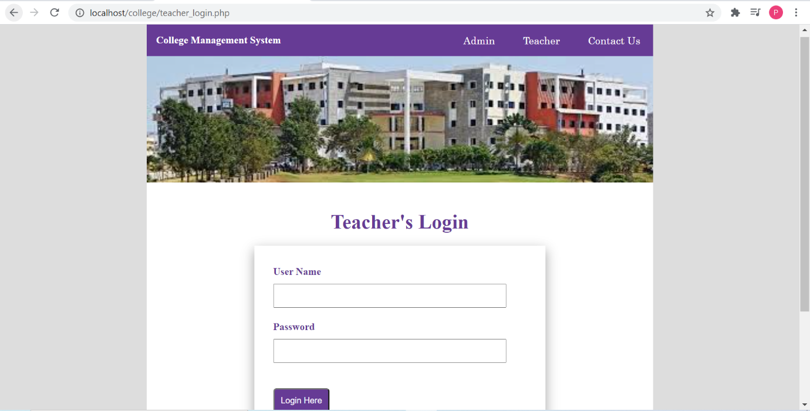

Teacher Login Page

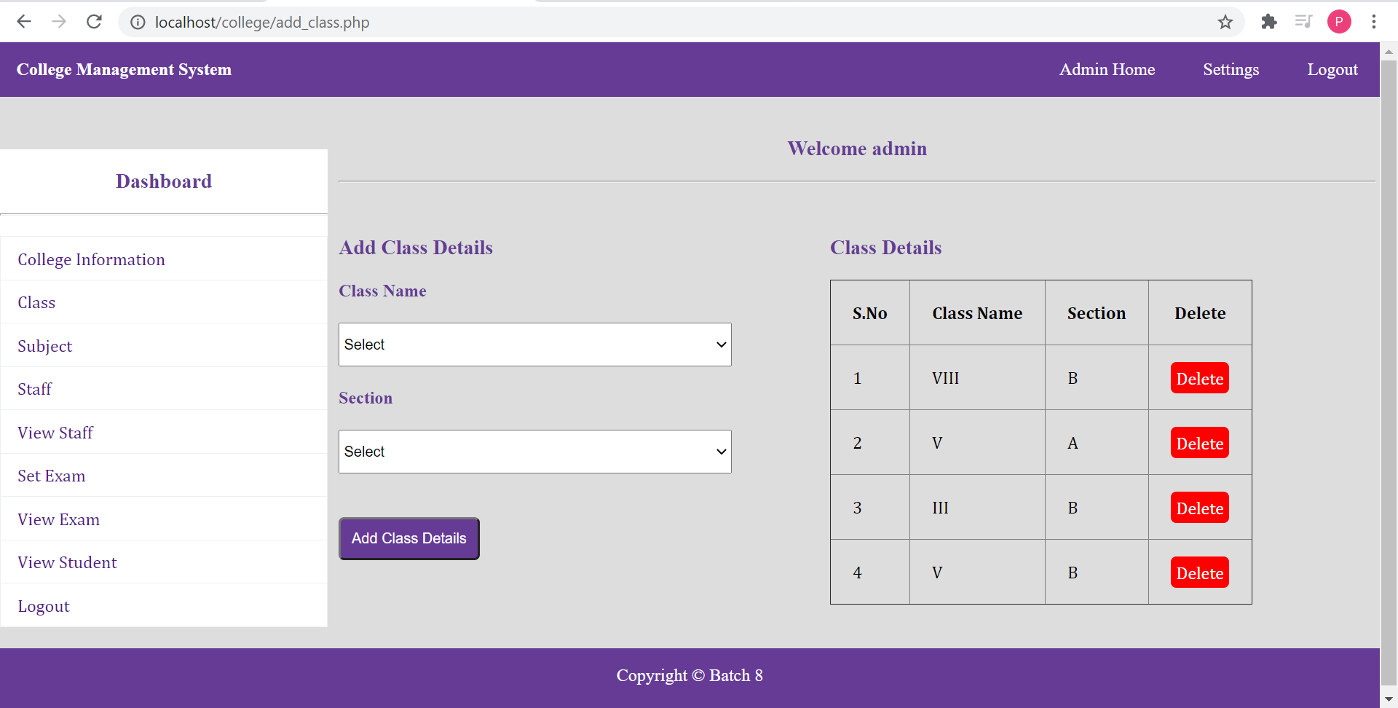

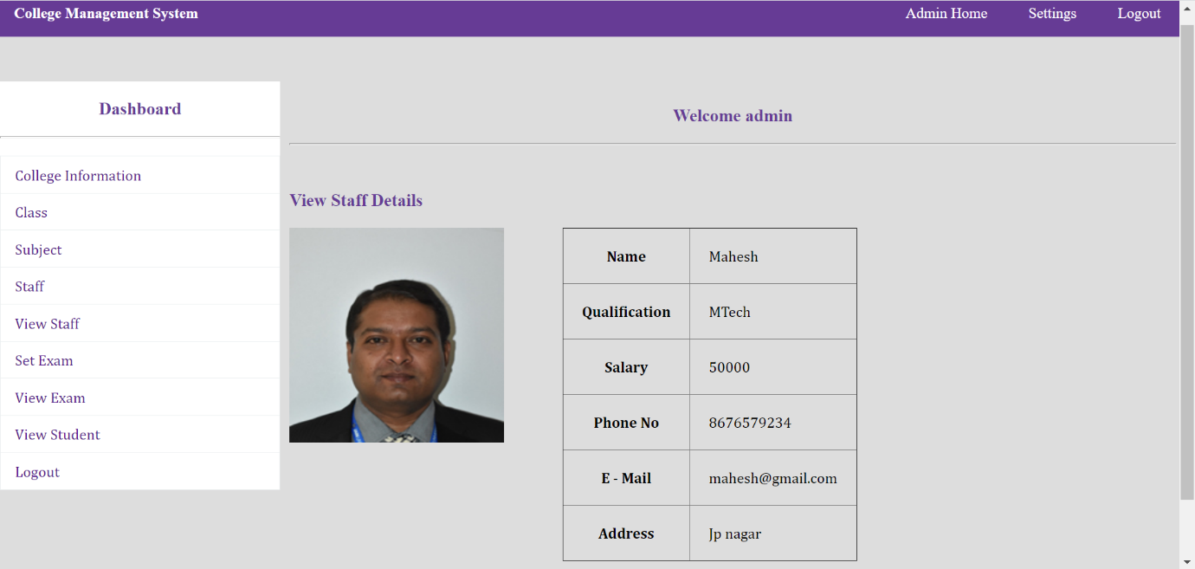

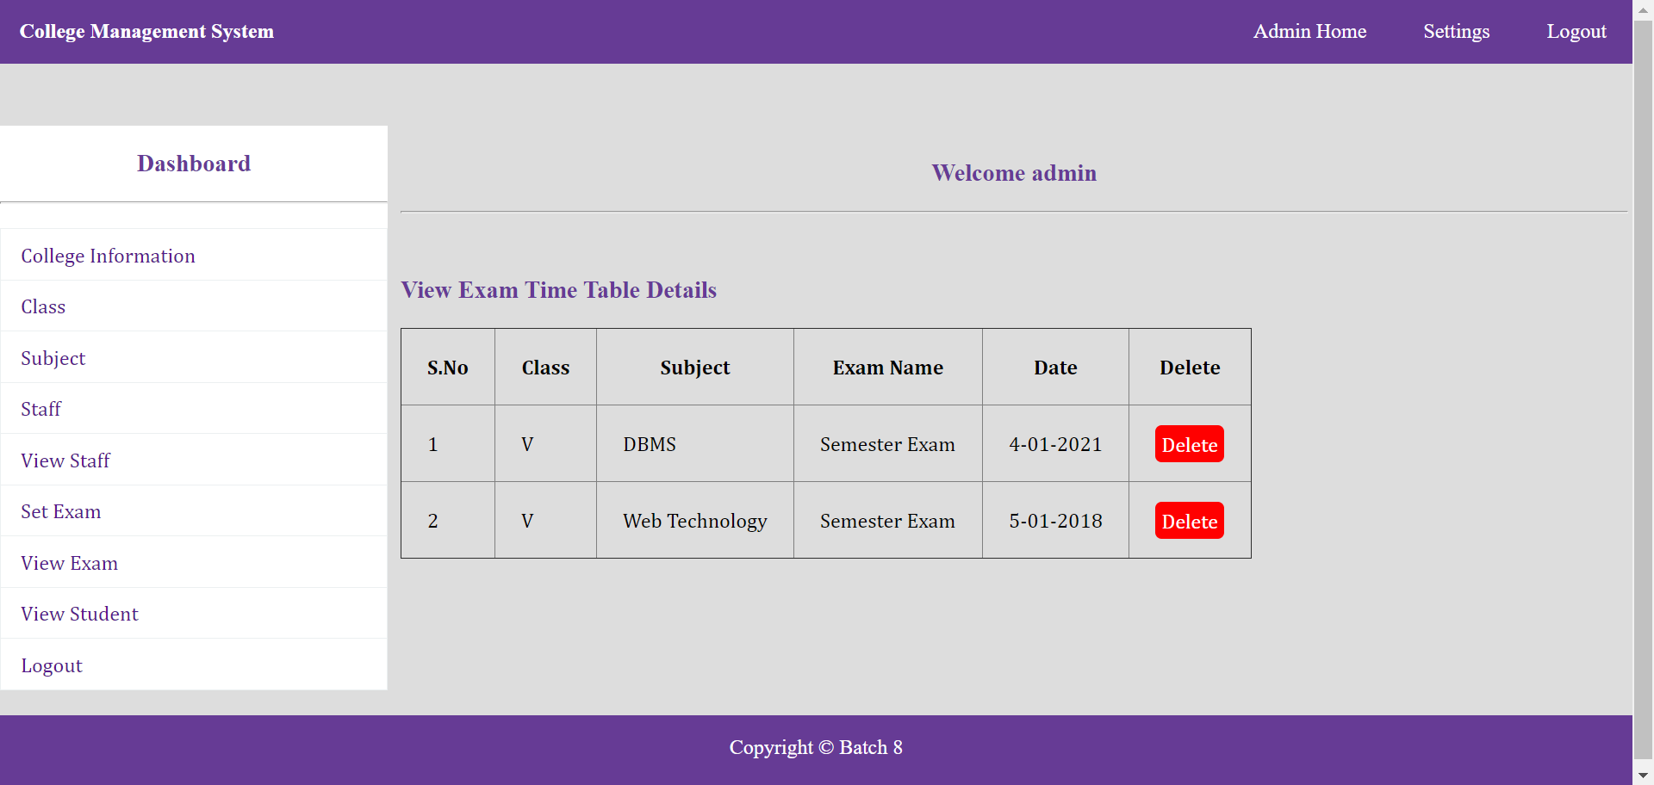

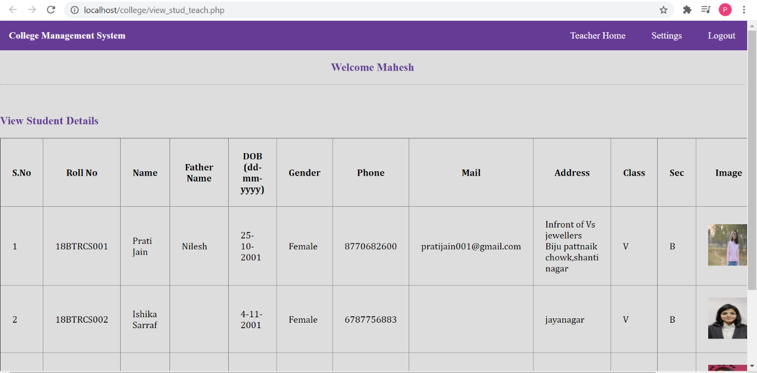

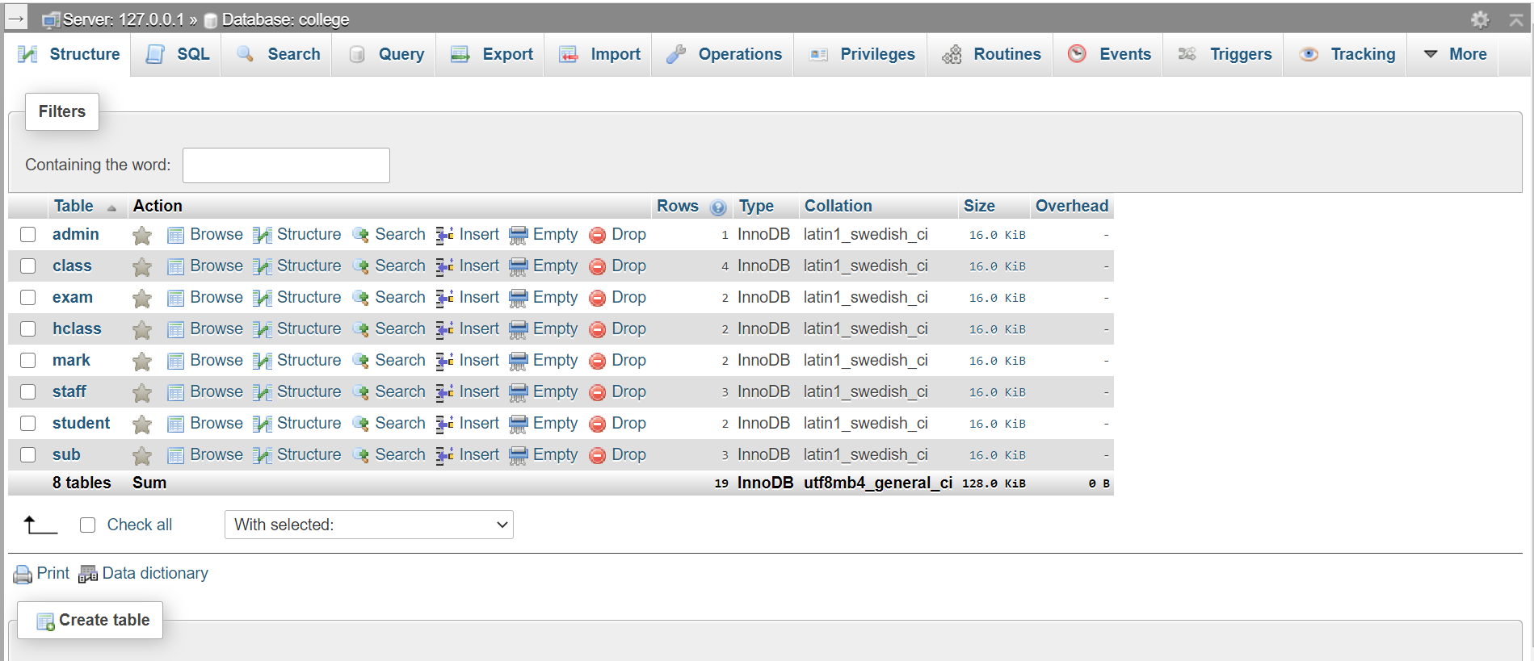

6 Conclusion

By using Existing System accessing information from files is a difficult task and there is no quick and easy way to keep the records of students and staff. Lack of automation is also there in the Existing System. The aim of Our System is to reduce the workload and to save significant staff time.

Title of the project as College ERP System is the system that deals with the issues related to a particular institution. It is the very useful to the student as well as the faculties to easy access to finding the details. The college ERP provides appropriate information to users based on their profiles and role in the system. This project is designed keeping in view the day-to-day problems faced by a college system.

This project is successfully implemented with all the features and modules of the college management system as per requirements.

7 References

1. Elmasri and Navathe: Fundamentals of Database Systems, 7th Edition, Pearson Education, 2016.
2. <https://www.w3schools.com/>
3. <https://www.tutorialspoint.com/>
4. <https://getbootstrap.com/>
5. <https://en.wikipedia.org>
6. JavaScript: The Complete Reference, 2013 by Thomas Powell, Fritz Schneider